**SQL Assignment - 1**

**Create table**

create table product

(

ProductID int Primary Key,

ProductName varchar(40),

SupplierID int,

CategoryID int,

QuantityPerUnit varchar(20),

UnitPrice decimal(10,4),

UnitsInStock smallint,

UnitsOnOrder smallint,

ReorderLevel smallint,

Discontinued bit

)

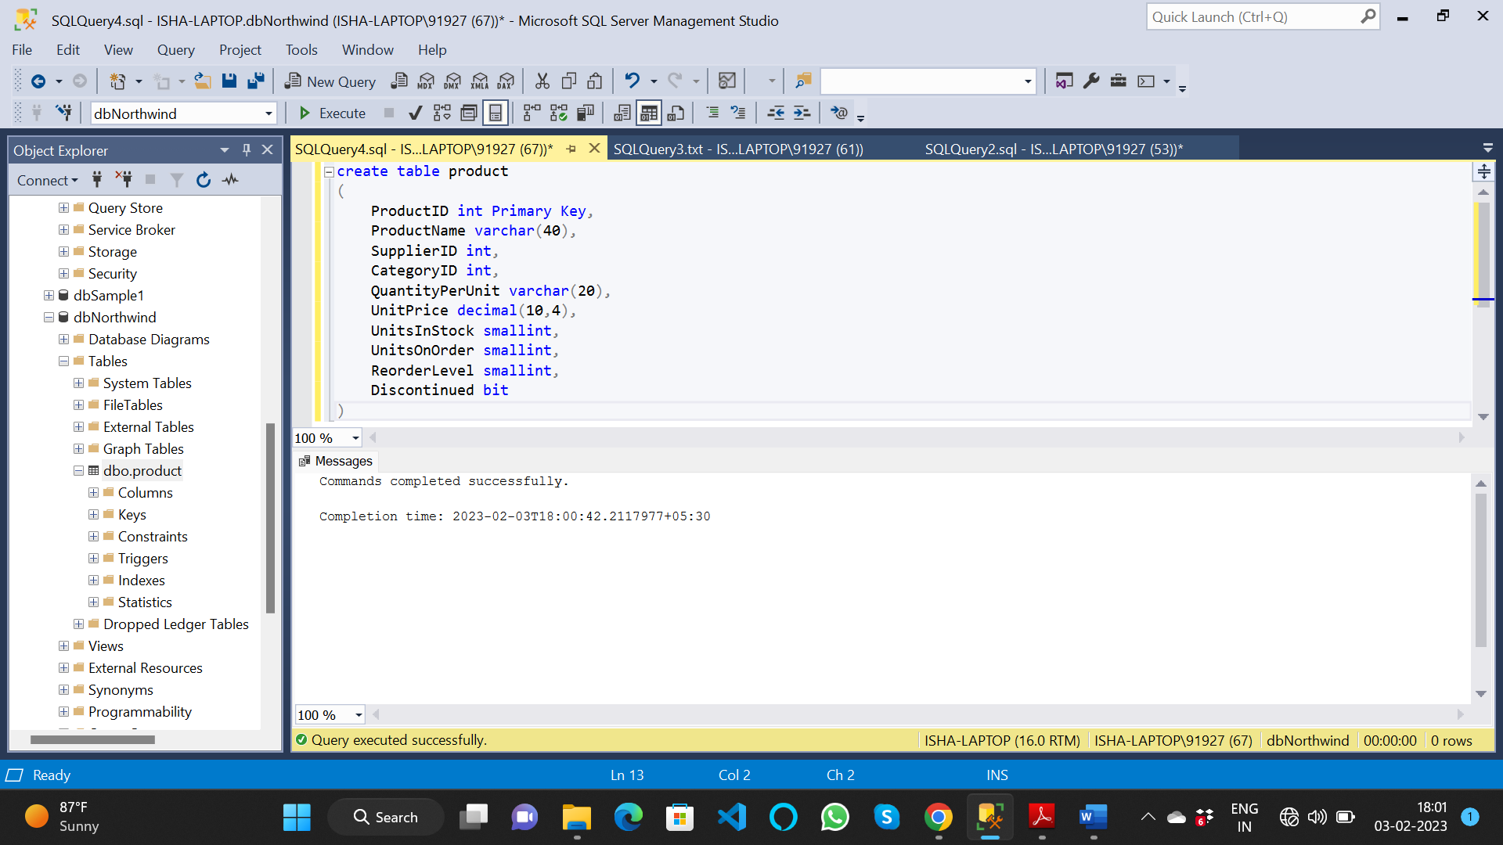

**Inserting the values to the table**

* Using query

insert into product values (1,'Chai',1,1,'10 boxes x 10 basgs',18,39,0,10,0)

insert into product values (2,'Chang',1,1,'24 - 12 oz bottles',19,17,40,25,0)

insert into product values (3,'Aniseed Syrup',1,2,'12 - 550 ml bottles',10,13,70,25,0)

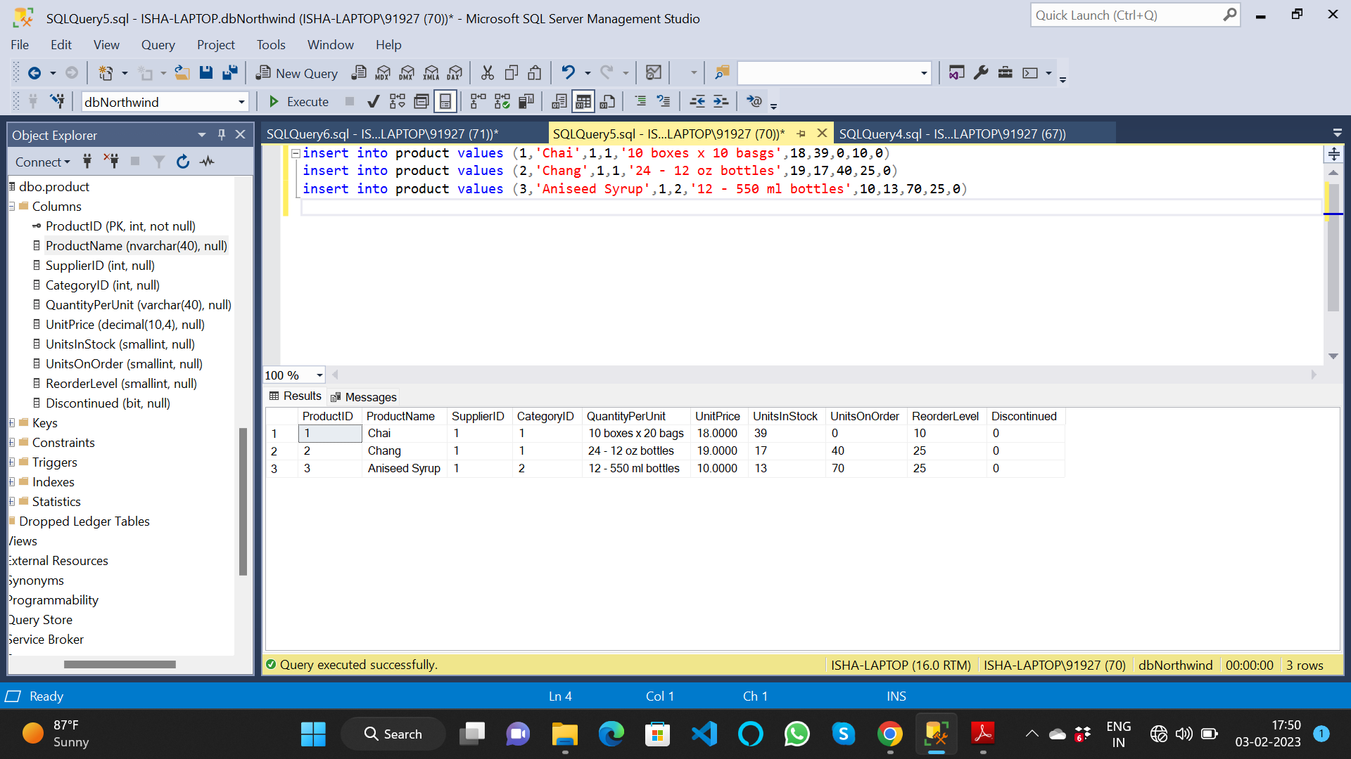

* Using UI

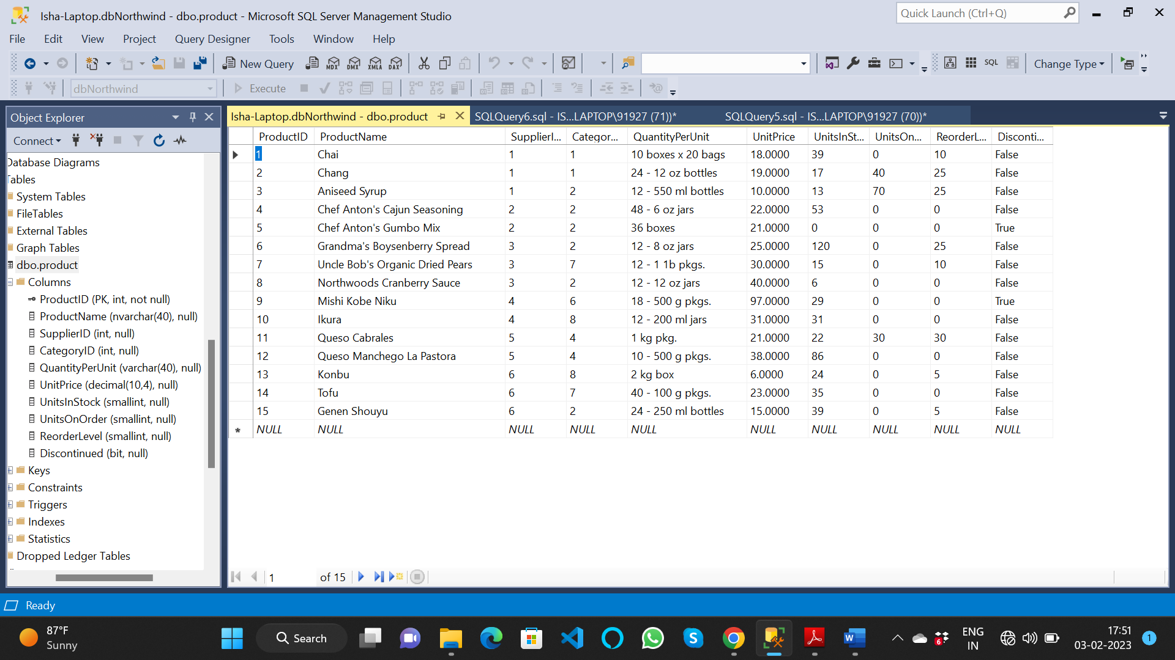

1. Write a query to get a Product list (id, name, unit price) where current products cost

less than $20.

* select ProductId, ProductName, UnitPrice from product where UnitPrice > 20

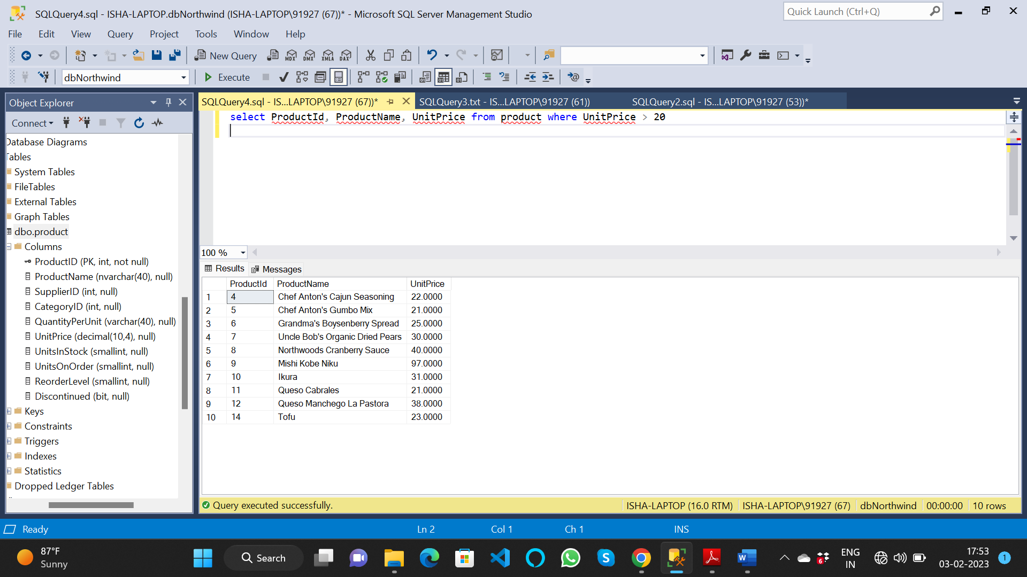

2. Write a query to get Product list (id, name, unit price) where products cost between

$15 and $25

* select ProductId, ProductName, UnitPrice from product where UnitPrice between 15 and 25

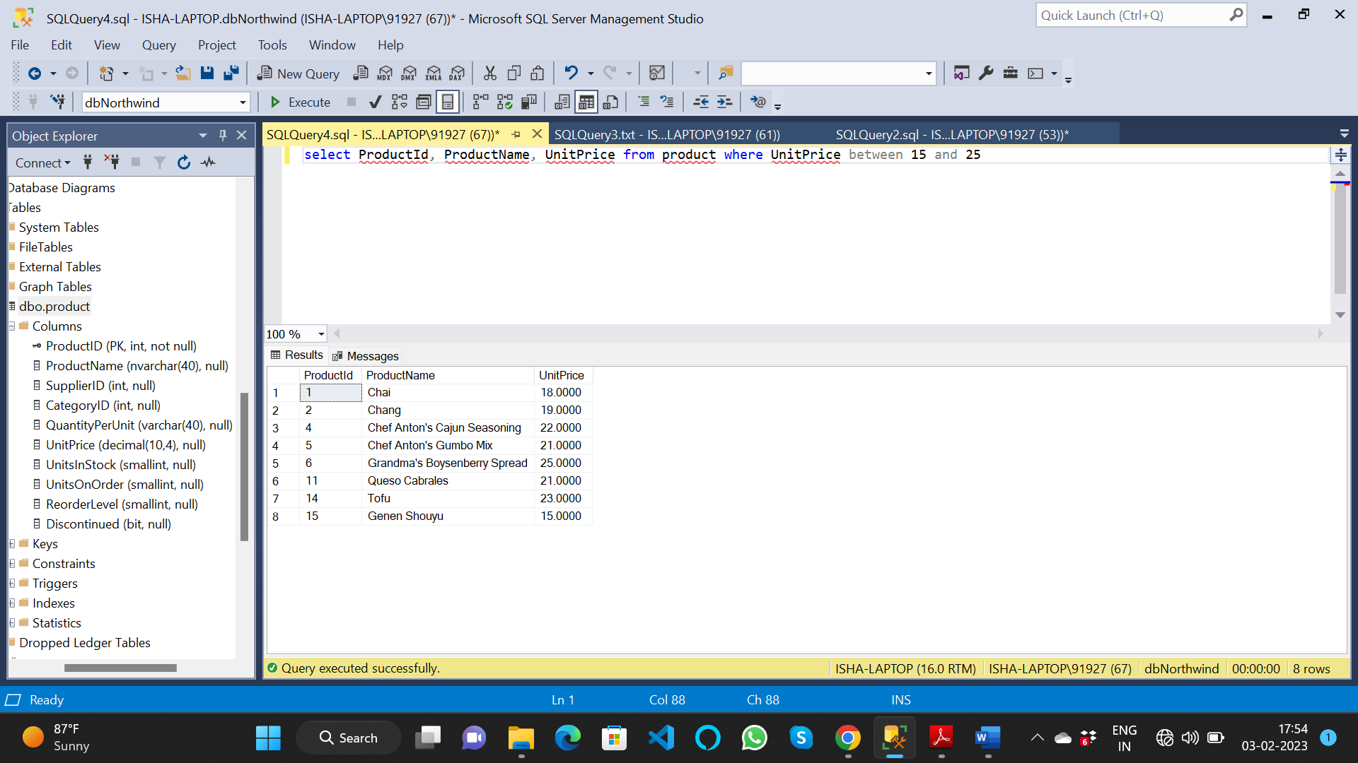

3. Write a query to get Product list (name, unit price) of above average price.

* select ProductName, UnitPrice from product where UnitPrice > (select avg(UnitPrice) from product)

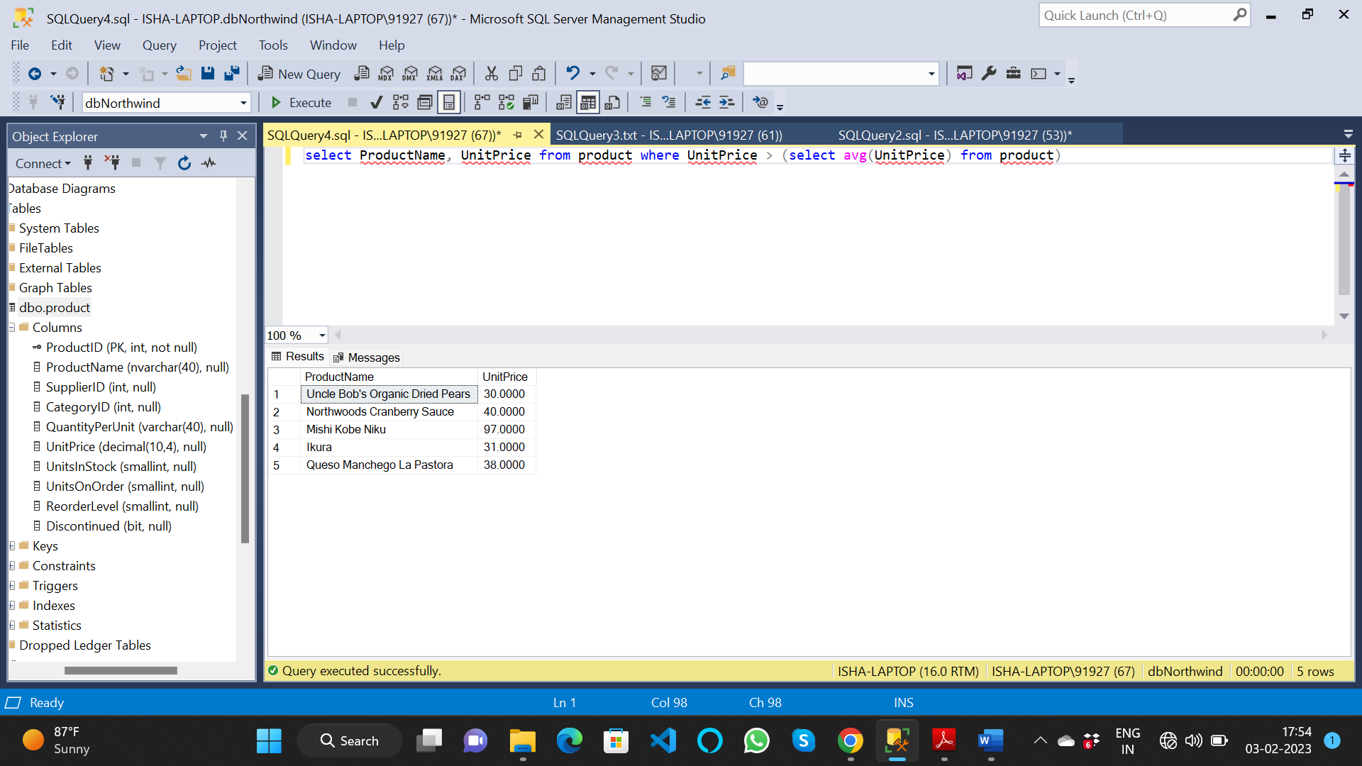

4. Write a query to get Product list (name, unit price) of ten most expensive products

* select top 10 ProductName, UnitPrice from product order by unitprice desc

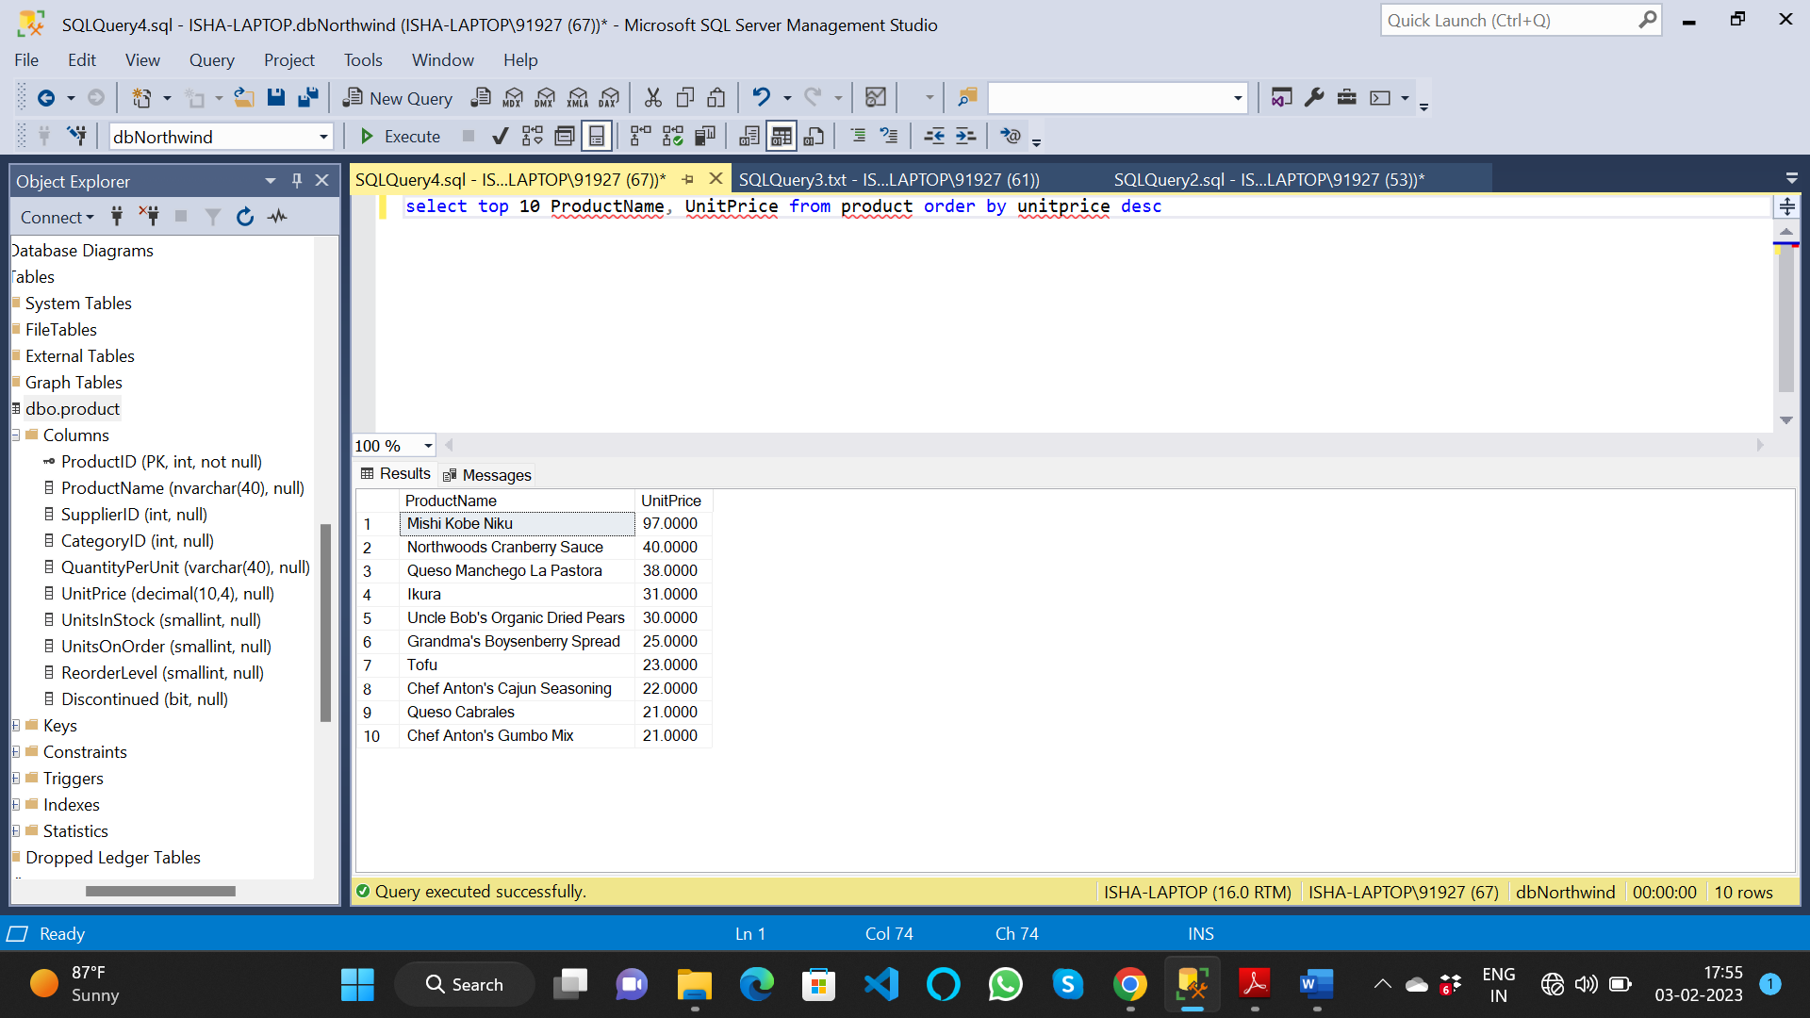

5. Write a query to count current and discontinued products

* select count(*) as [number of products] from product group by discontinued

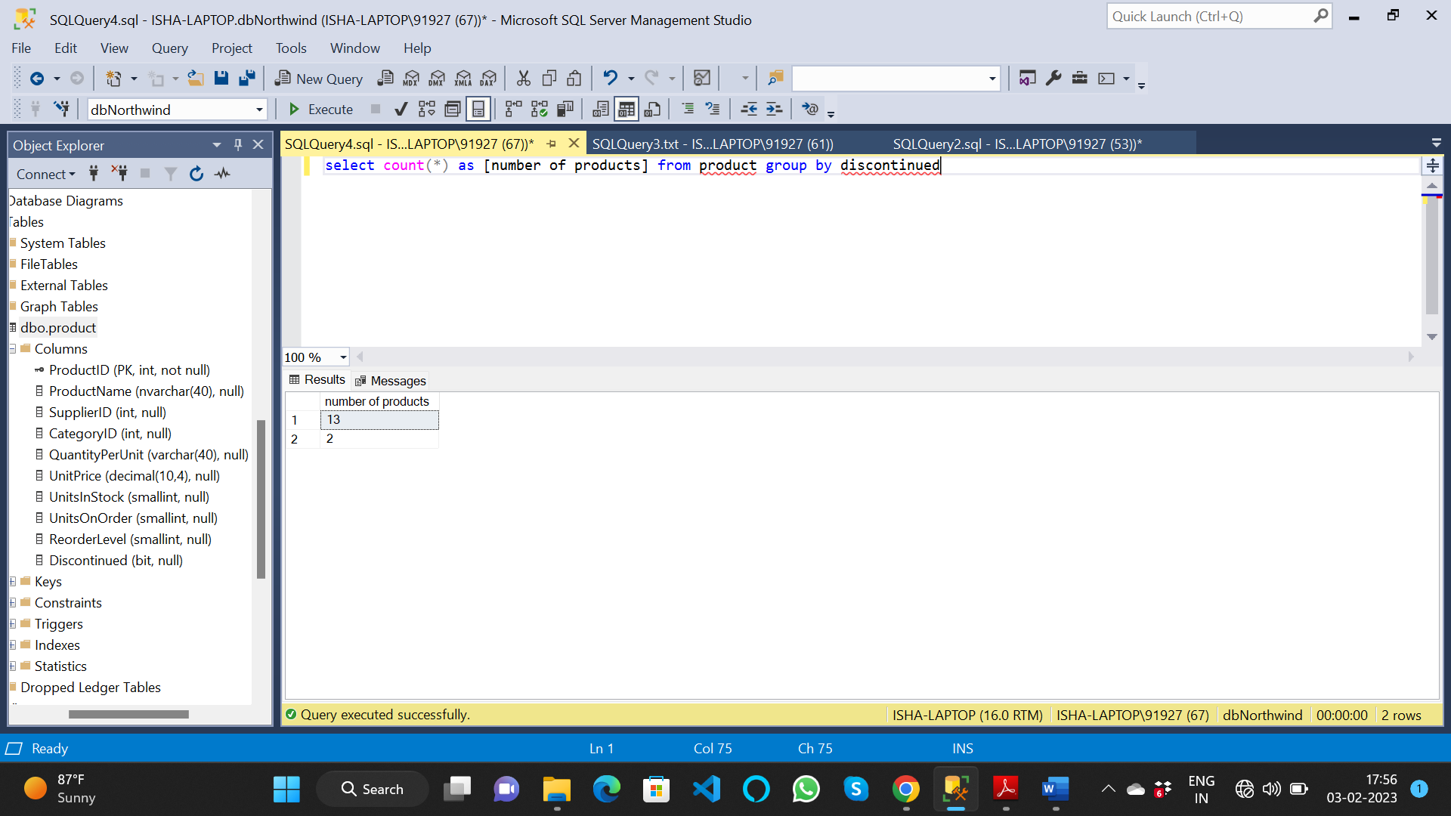

6. Write a query to get Product list (name, units on order , units in stock) of stock is less

than the quantity on order

* select productname, unitsonorder, unitsinstock from product where unitsinstock < unitsonorder

